POWER BI WEEK 1 PROJECT REPORT

Superstore Sales Data – Data Cleaning and Transformation
Name: Keerthana R
Roll No.: E25DA024
Department: B.Sc. DS and AI
Tool Used: Microsoft Power BI – Power Query Editor
Dataset: Sample Superstore Sales Data

1. Introduction
This project focuses on cleaning and transforming the Sample Superstore sales dataset using Microsoft Power BI. Power Query Editor was used to remove unwanted data, correct data types, standardize text values, and prepare the Order Date column for further analysis.

2. Objective
The main objective of this project is to clean and prepare the Superstore dataset so that the data becomes accurate, consistent, and ready for further analysis and visualization.

3. Dataset Description
The Sample Superstore dataset contains sales-related information such as Order Date, Ship Mode, Customer Name, Segment, Country, City, State, Region, Category, Sub-Category, Product Name, Sales, Quantity, Discount, and Profit.

4. Data Import
The Sample Superstore CSV file was imported into Microsoft Power BI. The data was opened in Power Query Editor to perform the required data cleaning and transformation operations.

5. Data Removal / Filtering
Unwanted or unnecessary data was filtered using the Filter Rows option in Power Query Editor. This helped to keep the required records for further analysis.

6. Change Data Type
The data types of the columns were checked and changed according to the type of data present in each column. Numerical, text, and date fields were assigned suitable data types.

7. Change Type Using Locale
The Order Date column was processed using the Change Type Using Locale option. The appropriate locale was selected so that the date values were interpreted correctly and converted into the required date format.
DATA TYPE :
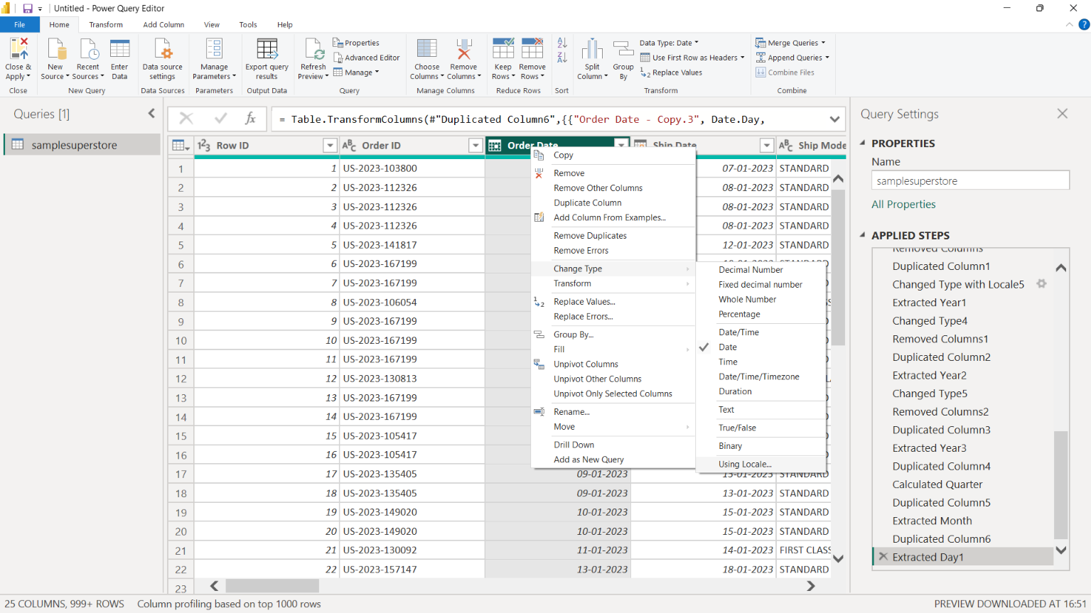

8. Duplicate Order Date Column
A duplicate copy of the Order Date column was created. The original Order Date column was preserved, while the copied column was used for further date transformations.

9. Trim and Clean
The text data was standardized using the Trim and Clean operations in Power Query.
Trim removes unnecessary spaces from text values.
Clean removes unwanted non-printable characters from text values.
These operations help maintain consistency in the dataset

TRIM:
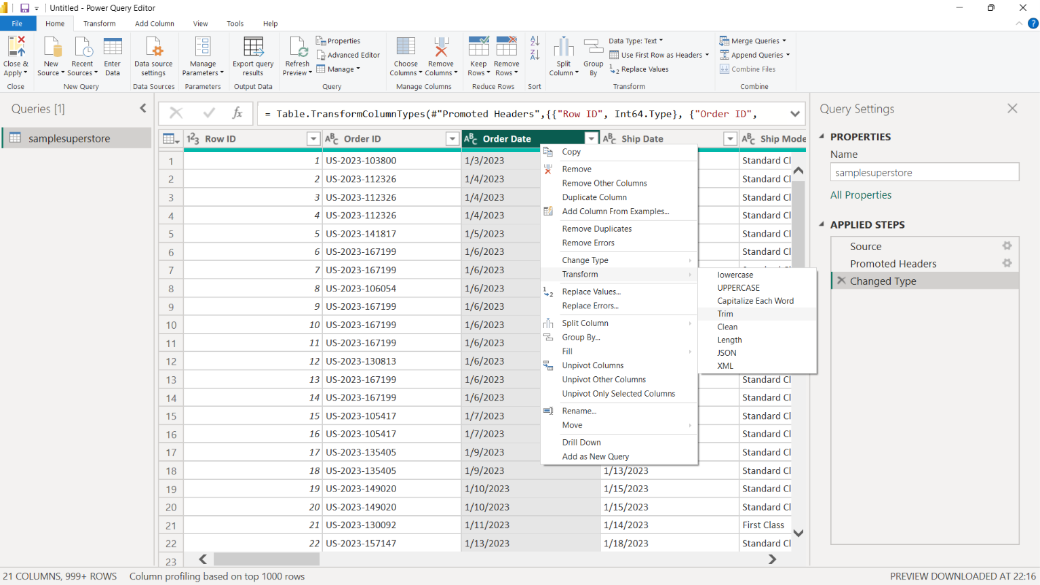

CLEAN:
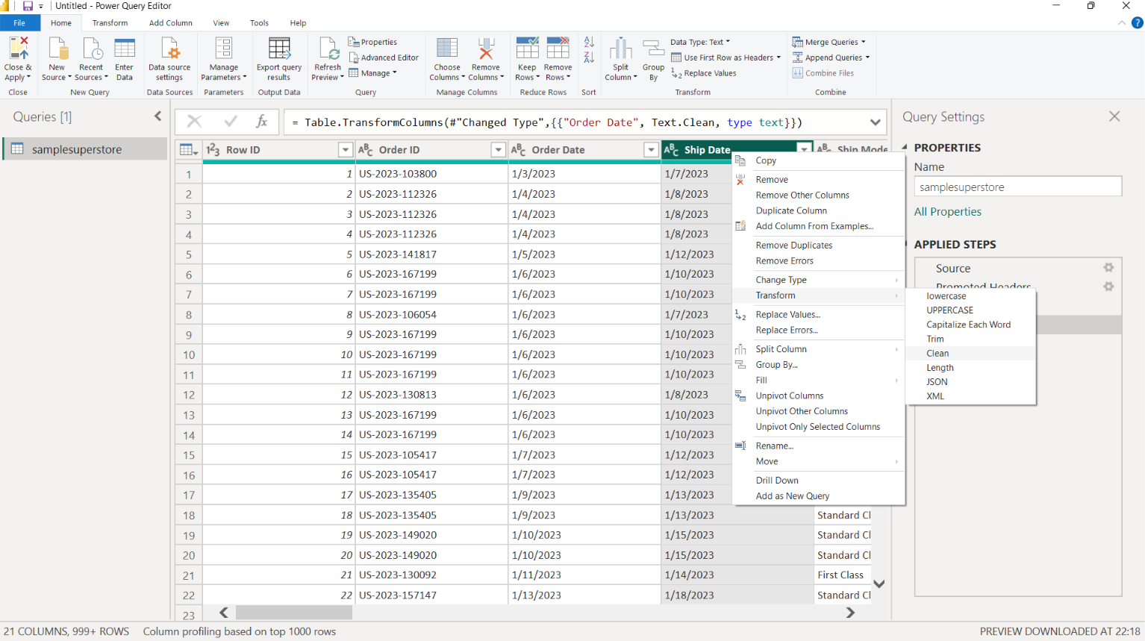

10. Date Transformation
The duplicated Order Date column was used to extract useful date information.
The following date attributes were created:
- Year
- Quarter
- Month
- Day
These fields can be used later for time-based analysis and visualization.

TRANSFORM DATA:
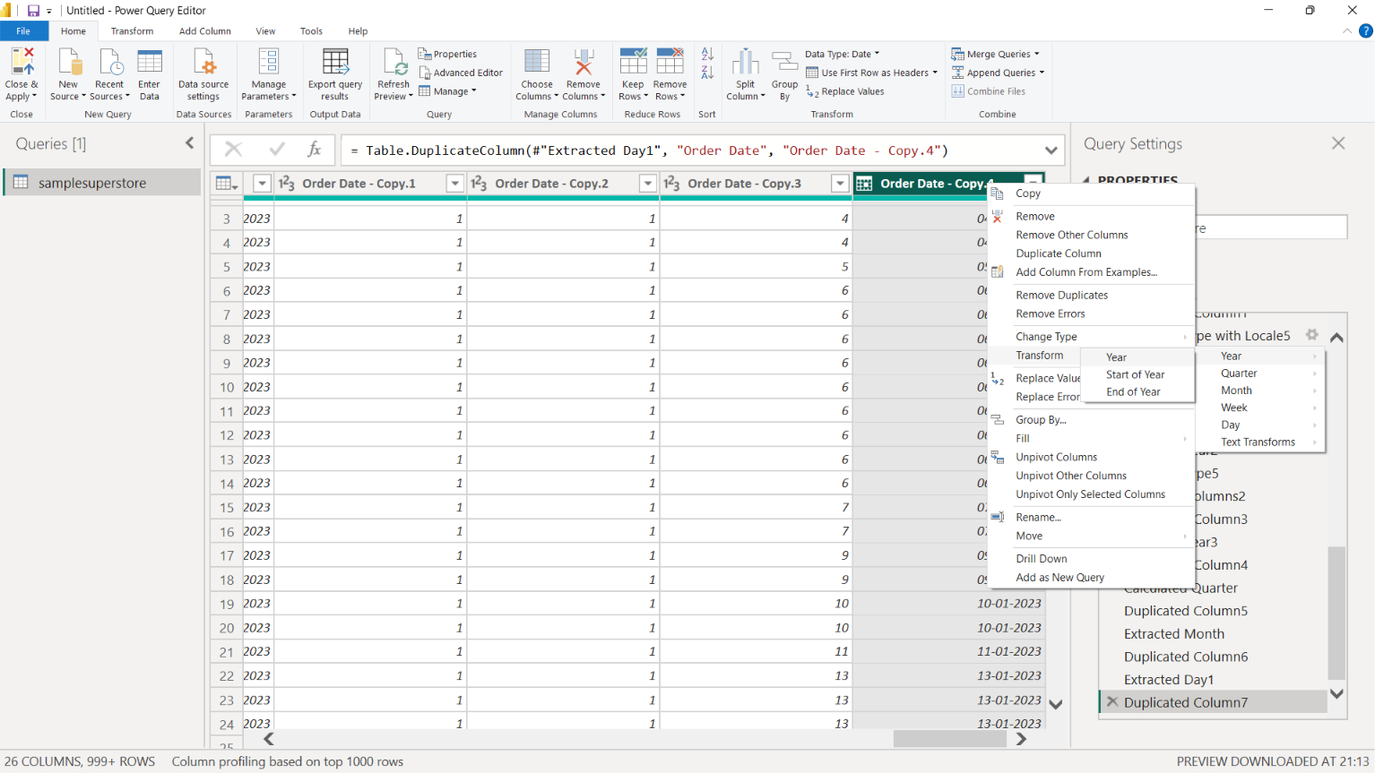

11. Duplicate Check
The dataset was checked for duplicate records using the duplicate-related options in Power Query. This was done to make sure repeated records would not unnecessarily affect the analysis.

REMOVE DUPLICATES:
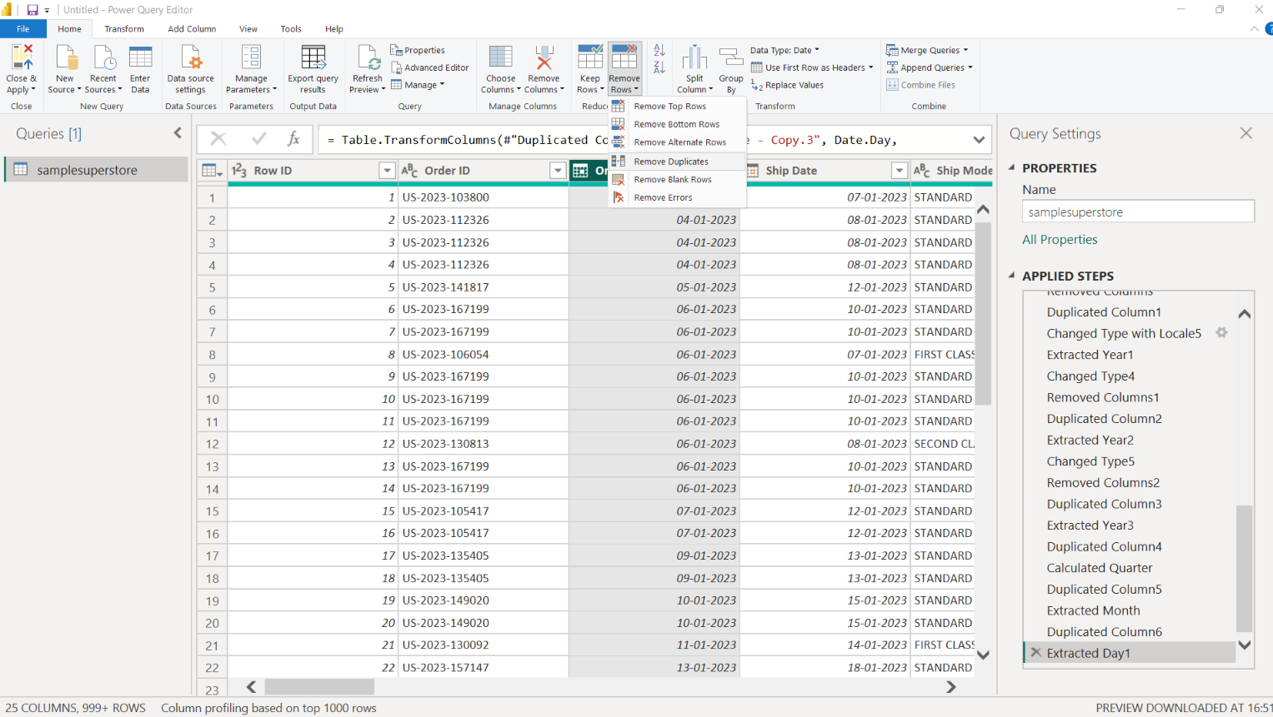

DUPLICATE CREATION :
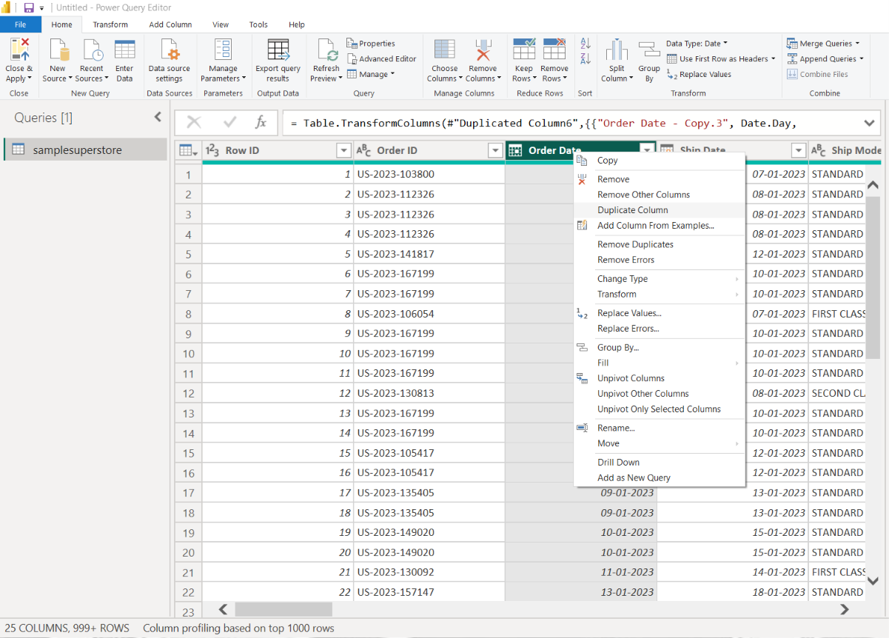

12. Final Data Preparation
After completing the required cleaning and transformation operations, the Superstore dataset was prepared for analysis. The data now contains corrected data types, standardized text values, and useful date attributes.

13. Result
The Sample Superstore dataset was successfully cleaned and transformed using Power Query Editor in Microsoft Power BI. The prepared dataset is ready for the next stage of the Power BI project.

14. Conclusion
This Week 1 project provided practical experience in data cleaning and transformation using Power BI Power Query Editor. The project covered filtering data, changing data types, using locale-based date conversion, creating duplicate columns, applying Trim and Clean operations, checking duplicates, and extracting date attributes.
The final dataset is now clean, consistent, and ready for further Power BI analysis and visualization.

